CARRAZ-BILLAT Armand

**TP 06 Internet Programming**

**URL :** [**https://armczbtgic.github.io/TP06/**](https://armczbtgic.github.io/TP06/)

1. **Exercice 1 : Infinite scroller**
   1. 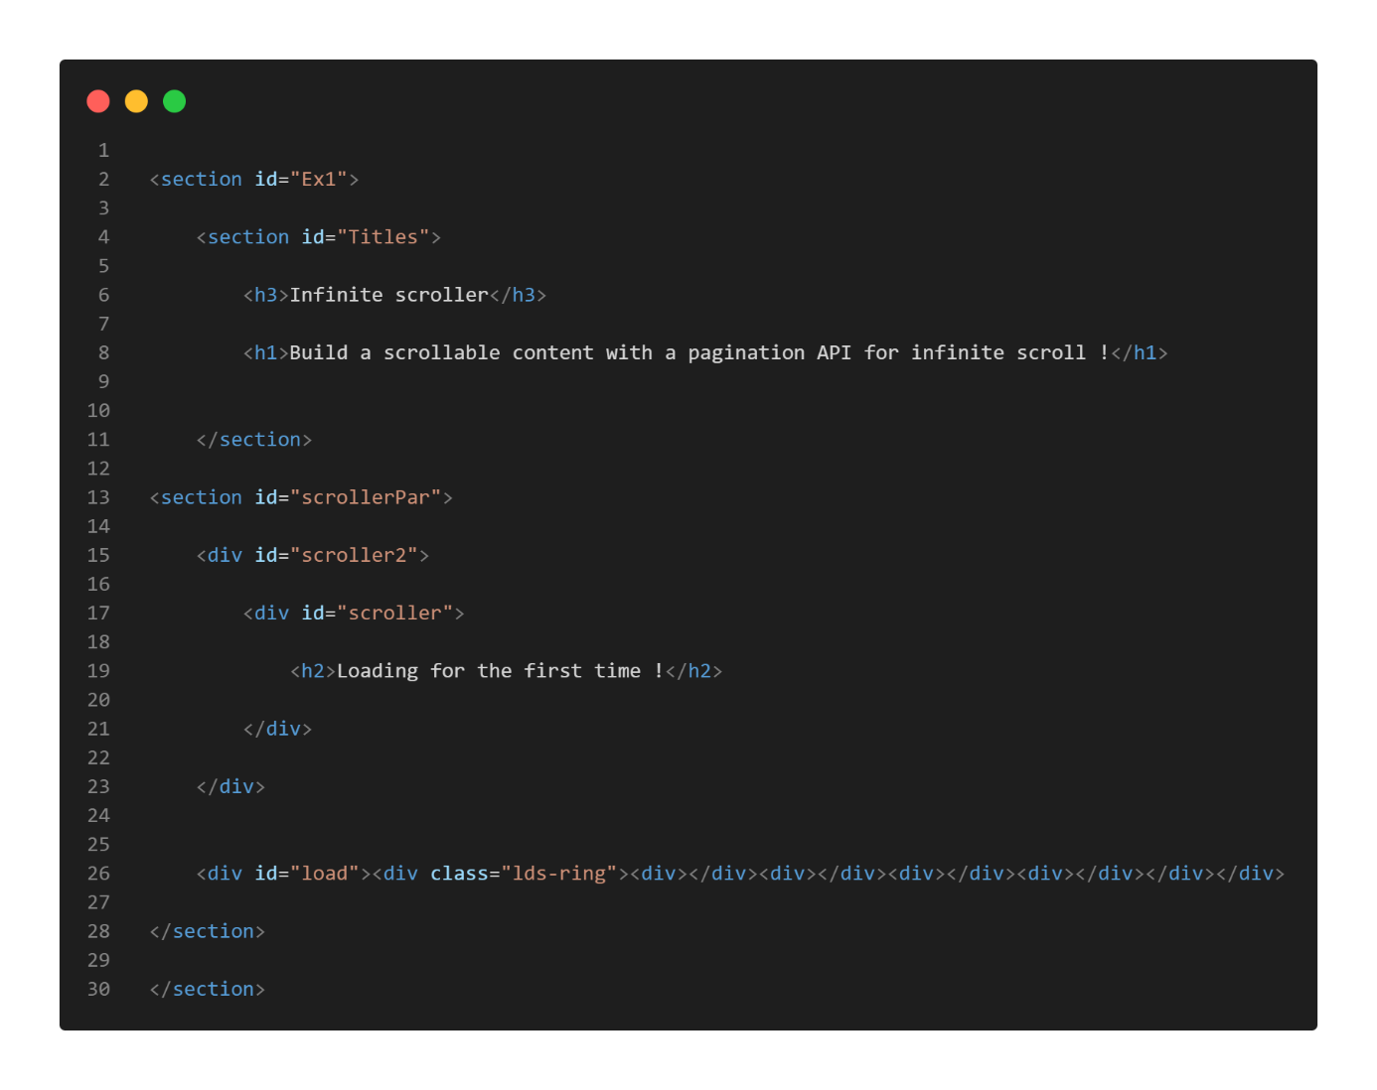**HTML**
   2. 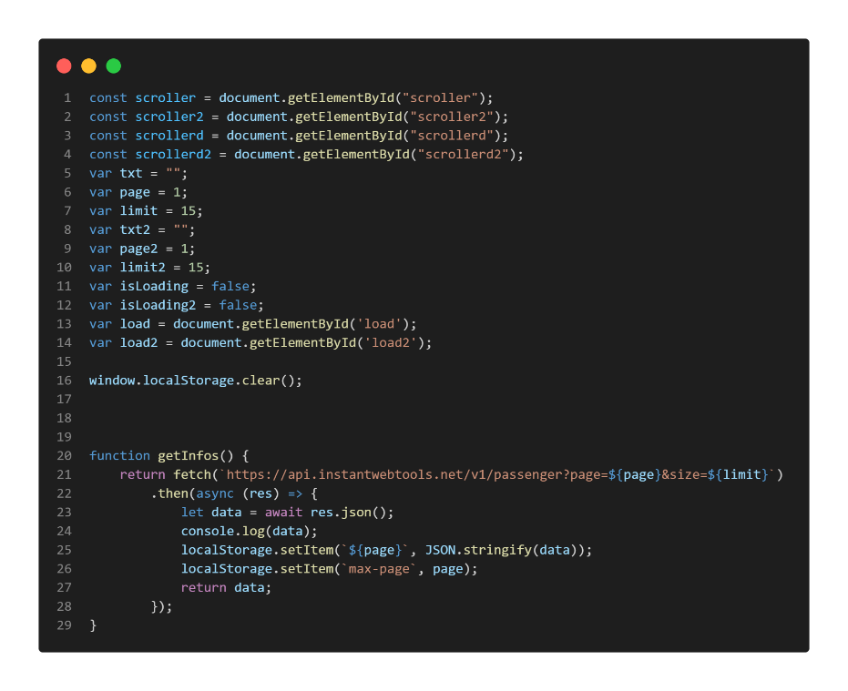**JavaScript**

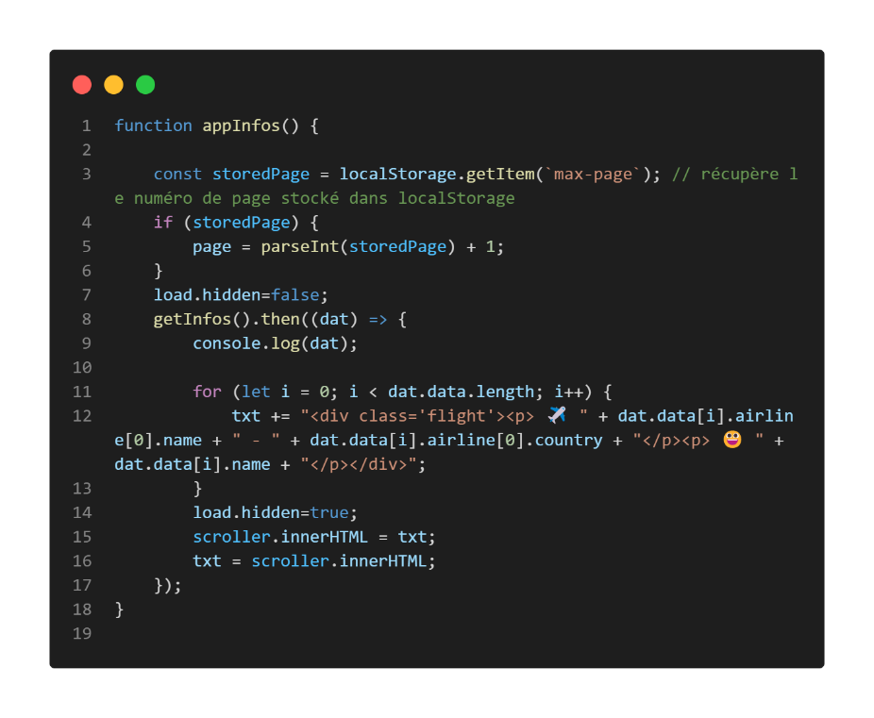

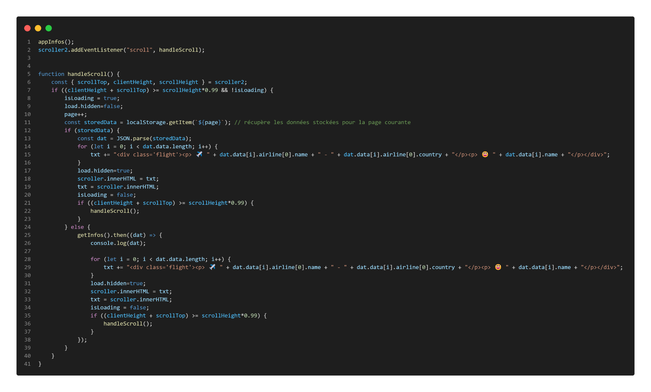

1. **Exercice 2 : Know Your Favorite Drink**
   1. **HTML**

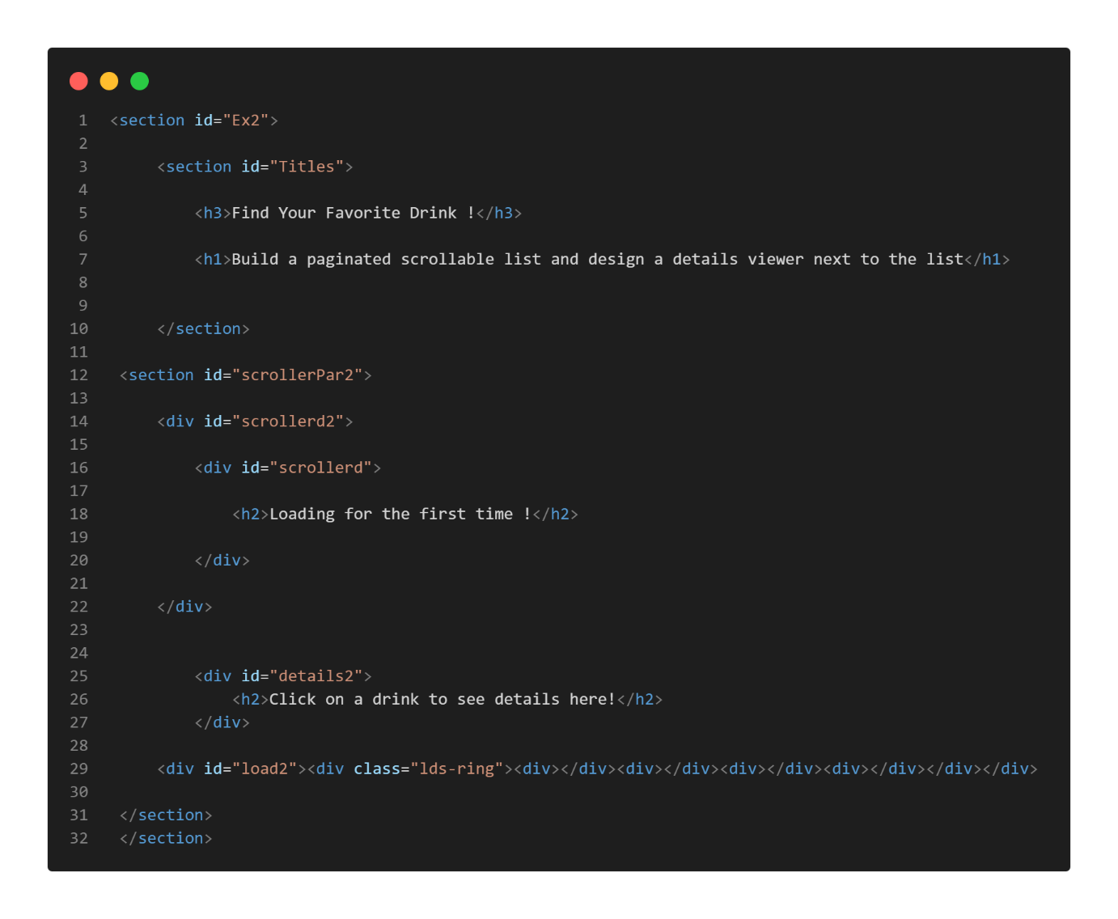

* 1. **JavaScript**

